Question.
As figure below, it’s a button with dropdown menu.

Please implement the UI component as figure below and follow the instruction.
- Please do NOT use any library such as jQuery, Dojo, angularJS, …and so on.
- Please consider the reusability, usability, and modularization.
- Please image you provide this component to other developers and must think how to let component can be configured easily.
- Please do consider the style as figure and try to do your best.
- It’s ok for using ES6+.

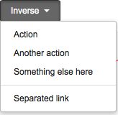

Feature:
1. A button can be clicked
2. When clicked, show dropdown menu.
3. Each of menu items is clickable
4. Separated function (line) between menu items
5. The items including separated line can be arbitrary order, that means it can be determined by developer.
Evaluation:
- Ease of use (function interface) (30%)
- Javascript OOP (40%)
- CSS concept (30%)

